

<(NAME) Project: (Workstream NAME)>

<Title: Base Specification Template>

<Version>.<Revision>.<Errata>

**Base Specification**

Effective XXXX, 2024

Author: <Primary>

Author: <Secondary. Delete if unnecessary>

**Table of Contents**

**1. License 3**

**1.1. Open Web Foundation (OWF) CLA** 3

**1.2. Acknowledgements 4**

**2. Compliance with OCP Tenets 5**

**2.1. Openness 5**

**2.2. Efficiency 5**

**2.3. Impact 5**

**2.4. Scale 6**

**2.5. Sustainability 6**

**3. Change Log 7**

**Current Template Version: 7**

**4. Scope 8**

**5. Overview 9**

**6. Environmental / Regulatory Requirements 10**

**7. Physical Specifications 11**

**7.1. Mechanical 12**

**8. Electrical Requirements 12**

**9. Thermal Design Requirements 13**

**10. Interfaces 13**

10.1. Signal List 14

**10.2 Rear Side Power, I/O, Expansion Board and Midplane Subsystems 14**

**11. Onboard Power System 15**

**12. Prescribed Materials 15**

**13. System Firmware 16**

**14. Hardware Management 16**

15. Compliance 17

**16. Security 17**

**17. Software Support (recommended) 18**

**18. Arm SystemReady (only for Arm-based Systems) 19**

**19. References 19**

**Appendix A - Checklist for IC approval of this Specification (to be completed by contributor(s) of this Spec) 20**

**Appendix B - Contribution Process FAQs 21**

# License

THE UPDATED DEFAULT CONTRIBUTOR LICENSE AGREEMENT (CLA) IS [**OWFa 0.9**](https://146a55aca6f00848c565-a7635525d40ac1c70300198708936b4e.ssl.cf1.rackcdn.com/images/ed0befaf86bee2568ad720ff4a9a554d1f4260f7.pdf). PLEASE VERIFY THE CORRECT CLA/FSA IS USED AND EXECUTED FOR THIS CONTRIBUTION.

## Open Web Foundation (OWF) CLA

Contributions to this Specification are made under the terms and conditions set forth in **Modified Open Web Foundation Agreement 0.9 (OWFa 0.9)**. (As of October 16, 2024) (“Contribution License”) by:

**[Contributor Name(s) or Company name(s)]**

Usage of this Specification is governed by the terms and conditions set forth in **Modified OWFa 0.9 Final Specification Agreement (FSA)** (As of October 16, 2024) **(“Specification License”).**

You can review the applicable Specification License(s) referenced above by the contributors to this Specification on the OCP website at <https://www.opencompute.org/contributions/templates-agreements>.

​​For actual executed copies of either agreement, please contact OCP directly.

**Notes**:

The above license does not apply to the Appendix or Appendices. The information in the Appendix or Appendices is for reference only and non-normative in nature.

NOTWITHSTANDING THE FOREGOING LICENSES, THIS SPECIFICATION IS PROVIDED BY OCP "AS IS" AND OCP EXPRESSLY DISCLAIMS ANY WARRANTIES (EXPRESS, IMPLIED, OR OTHERWISE), INCLUDING IMPLIED WARRANTIES OF MERCHANTABILITY, NON-INFRINGEMENT, FITNESS FOR A PARTICULAR PURPOSE, OR TITLE, RELATED TO THE SPECIFICATION. NOTICE IS HEREBY GIVEN, THAT OTHER RIGHTS NOT GRANTED AS SET FORTH ABOVE, INCLUDING WITHOUT LIMITATION, RIGHTS OF THIRD PARTIES WHO DID NOT EXECUTE THE ABOVE LICENSES, MAY BE IMPLICATED BY THE IMPLEMENTATION OF OR COMPLIANCE WITH THIS SPECIFICATION. OCP IS NOT RESPONSIBLE FOR IDENTIFYING RIGHTS FOR WHICH A LICENSE MAY BE REQUIRED IN ORDER TO IMPLEMENT THIS SPECIFICATION. THE ENTIRE RISK AS TO IMPLEMENTING OR OTHERWISE USING THE SPECIFICATION IS ASSUMED BY YOU. IN NO EVENT WILL OCP BE LIABLE TO YOU FOR ANY MONETARY DAMAGES WITH RESPECT TO ANY CLAIMS RELATED TO, OR ARISING OUT OF YOUR USE OF THIS SPECIFICATION, INCLUDING BUT NOT LIMITED TO ANY LIABILITY FOR LOST PROFITS OR ANY CONSEQUENTIAL, INCIDENTAL, INDIRECT, SPECIAL OR PUNITIVE DAMAGES OF ANY CHARACTER FROM ANY CAUSES OF ACTION OF ANY KIND WITH RESPECT TO THIS SPECIFICATION, WHETHER BASED ON BREACH OF CONTRACT, TORT (INCLUDING NEGLIGENCE), OR OTHERWISE, AND EVEN IF OCP HAS BEEN ADVISED OF THE POSSIBILITY OF SUCH DAMAGE.

## Acknowledgements

The Contributors of this Specification would like to acknowledge the following companies for their feedback:

List all companies or individuals who may have assisted you with the specification by providing feedback and suggestions but did not provide any IP.

| DELETE THIS BLOCK BEFORE SUBMITTING |
| --- |
| INSTRUCTIONS FOR THE FOLLOWING SECTIONS:   * The following sections, 2-5 are required for contribution. * Replace the section text (keep titles) * Please describe how this Specification complies to the following OCP tenets. Compliance is required for at least four of the five tenets (Sustainability is a required tenet). The ideals behind open sourcing stipulate that everyone benefits when we share and work together. Any open source project is designed to promote sharing of design elements with peers and to help them understand and adopt those contributions. There is no purpose in sharing if all parties aren't aligned with that philosophy. The OCP Incubation Committee will look beyond the contribution for evidence that the contributor is aligned with this philosophy. The contributor actions, past and present, are evidence of alignment and conviction to all the tenets. |

# 

# Compliance with OCP Tenets

Please describe how this Specification complies to the following OCP tenets. Compliance is required for at least four of the five tenets (Sustainability is a required tenet). The ideals behind open sourcing stipulate that everyone benefits when we share and work together. Any open source project is designed to promote sharing of design elements with peers and to help them understand and adopt those contributions. There is no purpose in sharing if all parties aren't aligned with that philosophy. The OCP Incubation Committee will look beyond the contribution for evidence that the contributor is aligned with this philosophy. The contributor actions, past and present, are evidence of alignment and conviction to all the tenets.

A full explanation of the OCP core tenets can be seen [here](https://146a55aca6f00848c565-a7635525d40ac1c70300198708936b4e.ssl.cf1.rackcdn.com/images/bf648bb75091907147e76846cad590f402660d2e.pdf).

## Openness

The measure of openness is the ability of a third party to build, modify, or personalize the device or platform from the contribution. OCP strives to achieve completely open platforms, inclusive of all programmable devices, firmware, software, and all mechanical and electrical design elements, including ancillary, external components or tools such as software utilities necessary to modify or use design contributions. Barriers to achieving this goal should be constantly addressed and actions taken to remove anything that prevents an open platform. Openness can also be demonstrated through collaboration and willingness to share, seek feedback, and accept changes to design and specification contributions under consideration. Ensure this contribution can be extended and enhanced by others.

## Efficiency

Continuous improvement has been a fundamental value of the industry. New contributions (and updates to existing contributions) shall be more efficient than existing or prior generation contributions. Efficiency can be measured in many ways - OpEx and CapEx reduction, performance, modularity, capacity, power or water consumption, raw materials, utilization, size or floorspace are some examples. The goal is to express efficiency with clear metrics, valued by end-users, when the contribution is proposed.

## Impact

OCP contributions should have a transformative impact on the industry. This impact can come from introducing new technology, time-to-market advantage of technology, and/or enabling technology through supply chains that deliver to many customers in many regions of the world. New technologies are impactful when such technology is enabled through a global supply channel. One example is the NIC 3.0 specification which achieved global impact by having over 12 companies author, adopt, and supply products that conformed to the specification. Another example is emerging and open security features that establish and verify trust of a product

## Scale

OCP contributions should be designed such that end products may be easily implemented and/or deployed, irrespective of quantity, with minimal intervention. Ensure all necessary tools, such as supporting documentation, etc., are included in the final contribution.

## **Sustainability**

OCP contributions must be sustainable. Submissions should maximize transparency of

environmental impacts of the contribution, with the aspiration of improvement over time.

Other focuses:

* Conscientious use of our natural resources (land, air, power, water and materials)
* Fostering positive societal impacts
* Minimizing Environmental Harm

Practically this can be realized in a base specification as high level design requirements, or architectural decisions, for example, that reflect this intent.

# Change Log

Note, refer to the OCP Contribution Versions, Revisions and Errata best practices documentation. Generally speaking, Versions and revisions are made to this document and logged here. Errata is a separate document such that the contribution specification document it refers to was not revised. Ex: Version 1, Errata E1

| **Date** | **Version #** | **Author** | **Description** |
| --- | --- | --- | --- |
| 03 JUL 23 | 1.1 | Bijan Nowroozi | Edited the goals in the overview for clarity |
| 08 AUG 23 | 1.2 | Bijan Nowroozi | Changed some of the sustainability text |
| 06 NOV 23 | 1.3 | Bijan Nowroozi | Terminology changes and edits for clarity |
| 30 SEP 24 | 1.4 (RC) | Bijan Nowroozi | Added usage note and compliance sections, updated numbering |
| 04 NOV 24 | 1.4 | Bijan Nowroozi | Reflected New License |
|  |  |  |  |
|  |  |  |  |

# Current Template Version:

OCP Modular Base Specification Template V1.4.0

# 

# Scope

This document defines a Hardware Base Specification.

The Base Specification is an architectural framework for coarse alignment— a requirements description for flexible hardware and software modules to interoperate. Market requirements drive Base Specifications. Without defining details of a specific design, the Base Specification may be light on IP content. This structure enables and simplifies the process for multiple parties (including potential competitors) to engage in this phase.

Please see the [presentation](https://146a55aca6f00848c565-a7635525d40ac1c70300198708936b4e.ssl.cf1.rackcdn.com/images/4d14a1280e13c7dcf17123678eedc7e56053de96.pdf) and [recording](https://www.youtube.com/watch?v=IKqGFyE0V9E) on the Modular Contribution Process from the OCP Global Summit 2022 for more information.

This document defines the technical details for one of the following types of specifications:

* base specification for a de-facto standard (new standard with no hardware product)
* base specification for an intended physical <hardware product type>
* modification of an existing specification (state which existing spec is being modified)
  + either a complete revision update or
  + a minor version update

Note: Any supplier seeking OCP recognition for a hardware product must be 100% compliant with these Base requirements and subsequent design and product specifications as described.

Examples are provided for reference only and can be found in the OCP Contribution Portal:

De-facto Standard -

Cooling Environments: [Immersion Fluid Specification](https://www.opencompute.org/documents/ocp-base-specification-for-immersion-fluids-20221201-pdf) *

Server - [DC-MHS Modular Specifications](https://www.opencompute.org/contributions?query=dcmhs&configure%5BfacetFilters%5D%5B0%5D=archived%3Afalse) *

Network - [DS1000 Ethernet Access Switch Hardware Specification](https://www.opencompute.org/documents/ds1000ethernetaccesswitch-docx-pdf)

Rack - [ORV3 Base Specification](https://www.opencompute.org/documents/open-rack-base-specification-version-3-pdf)*

Storage -

Cards - [Open Accelerator Infrastructure (OAI) - Universal Baseboard (UBB) Specification](https://www.opencompute.org/documents/oai-ubb-base-specification-r2-0-v0-5-2-pdf)

Revision Update -

Version Update -

* Note: Few Base Specifications were submitted prior to the final approved template.

# Overview

Describe your contribution or product. Include the problems it addresses. Explain its utility within the Open Compute Project ecosystem.

***INSTRUCTIONS FOR ALL FOLLOWING SECTIONS:***

* *Sections 6 – 17 are modeled on the required sections to document features and functions of the Hardware system, platform or card. If a section is not applicable to your contribution, you may delete any extra components.*
* *Where possible, please use the* [*OCP Terminology Guidelines for Inclusion and Openness*](https://www.opencompute.org/documents/ocp-terminology-guidelines-for-inclusion-and-openness)*.*
* *No NDA (Non-disclosure Agreement) or confidential material should be included in the document or charts. This will be an OPEN document.*

# Environmental / Regulatory Requirements

*Please describe any environmental regulations or requirements for any platform boards and full system, if applicable..*

*Note to author of this specification: This section can include the following but is not limited to the below items:*

* *UL/CE/NRTL/FCC/IEC/EN/etc Requirements*
* *RoHS/WEE directives, REACH regulations*
* *NEBS compliance requirements*
* *Operating temperature range*
* *Storage temperature range*
* *Transportation temperature range*
* *Shock and Vibration requirements*
* *Operating Altitude*

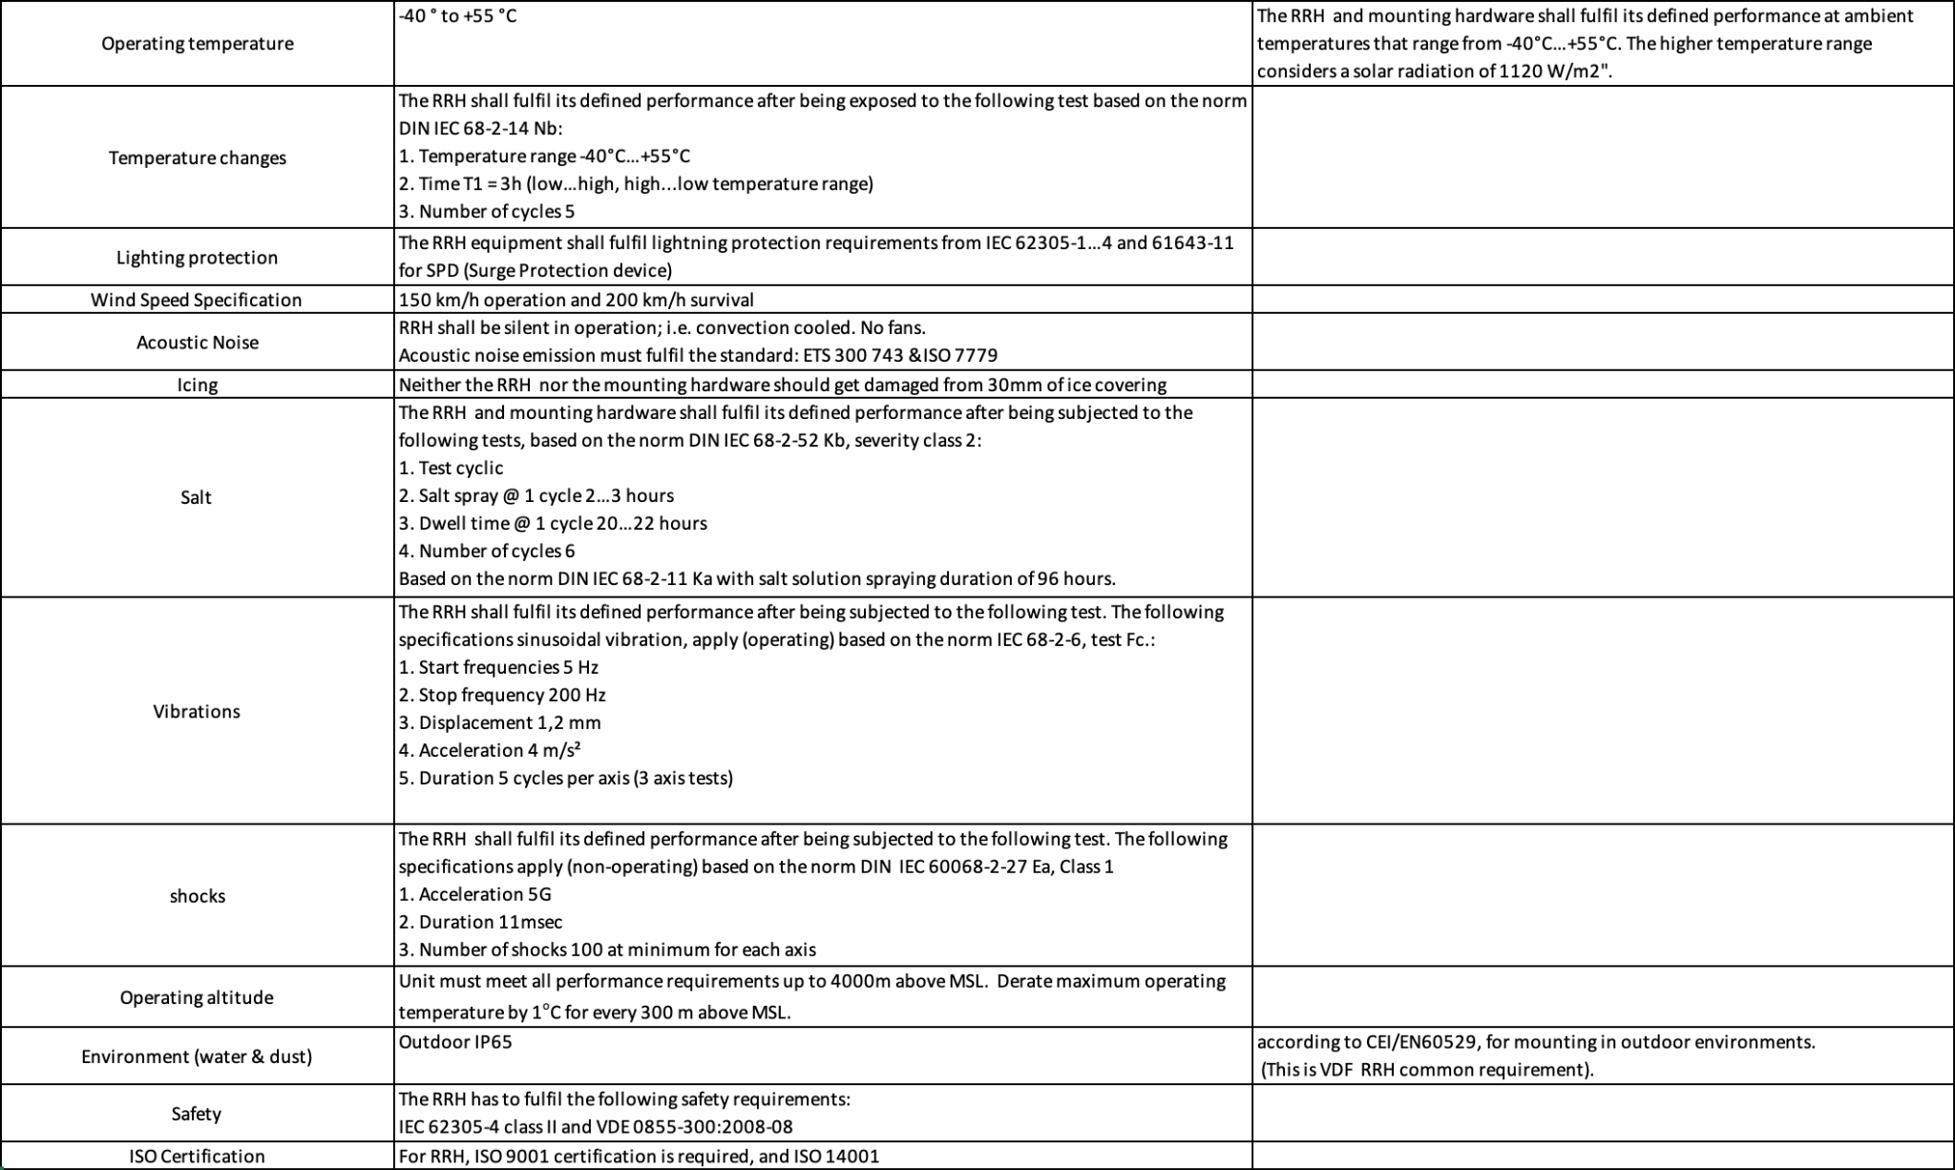

Example Outdoor Equipment Environmental Requirements

# Physical Specifications

*Please describe the physical requirements for your contribution. This may be the limitations of the physical envelope.*

*If this specification defines a chassis type system, be sure to include the description of the chassis and associated modules, midplane, backplanes etc….*

*Note to author of this specification: This section can include the following but is not limited to the below items:*

* *Block Diagrams*
* *Form Factor Requirements*
* *Figures & Illustrations*

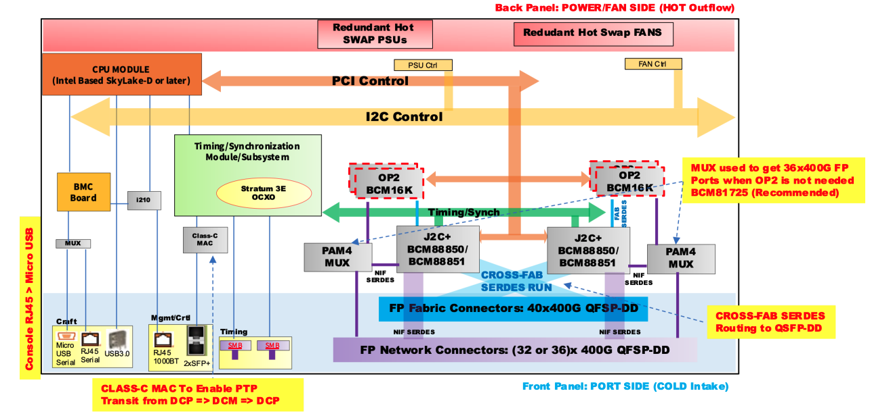

Sample Block Diagram

## Mechanical

*Please describe any key mechanical requirements of your contribution.*

*Note to author of this specification: This section can include the following but is not limited to the below items:*

* *Chassis*
* *Single sled/double sled*

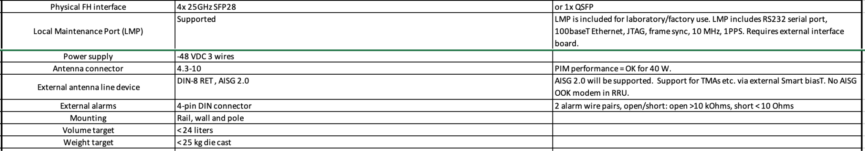

Dual-Band RRU Mechanical Requirements

# Electrical Requirements

*Please describe general electrical power requirements. Example: Power Input envelope +48VDC, 110VAC, peak/average power, etc…*

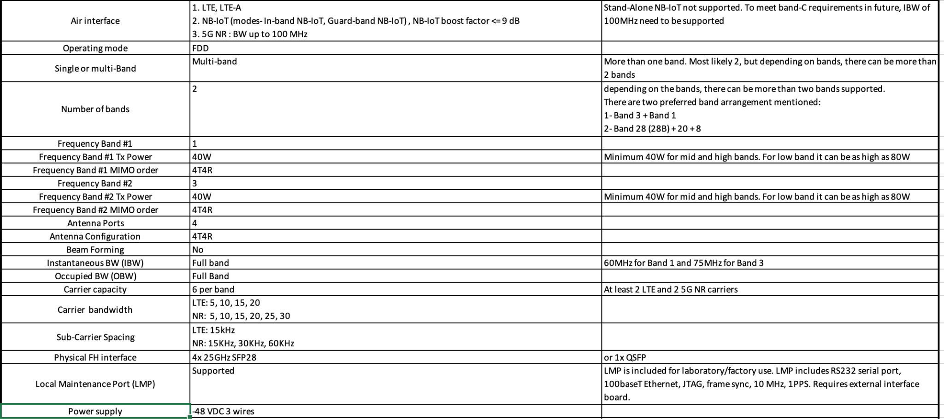

Dual-Band RRU Electrical Requirements

# Thermal Design Requirements

*Please describe the thermal design requirements for your contribution and any CFD and/or thermal models etc...*

*Note to author of this specification: Examples include:*

* *Cooling Media*
* *Flow Management*
* *Fan Controls*

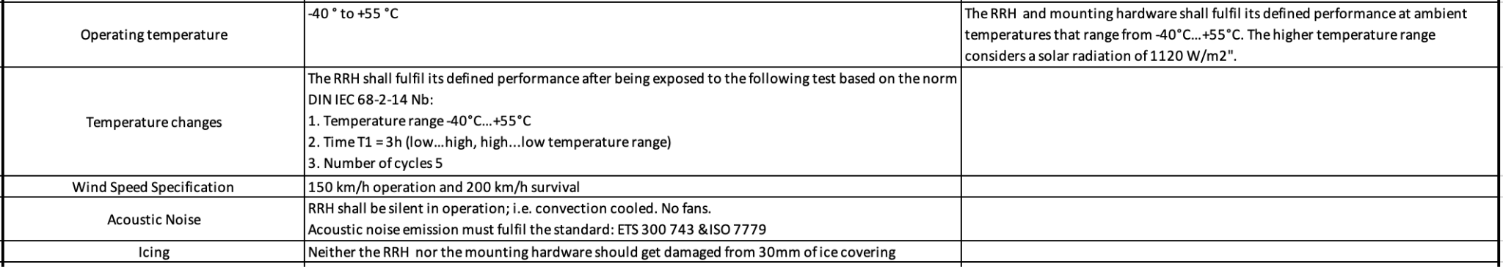

Dual-Band RRU Thermal Requirements

# Interfaces

*Please describe the I/O System of the contribution, be sure to delineate the control and data planes. Block diagrams here.*

**

## Signal List

*Note to author of this specification: Examples only*

* *Power and Ground*
* *Synchronization/Clocks*
* *PCIe*
* *i2C/i3C*
* *GPIO*
* *USB 3.0*

## 10.2 Rear Side Power, I/O, Expansion Board and Midplane Subsystems

*Please describe any modular design implementation requirements of the contribution.*

*Note to author of this specification: This section can include the following but is not limited to the below items:*

* *​​Overview of Footprint and Population Options*
* *Rear Side Connectivity*
* *Midplane*
* *Expansion*
* *Fixed, redundant, modular, pluggable, adapter?*
* *Power, Grounding etc…*

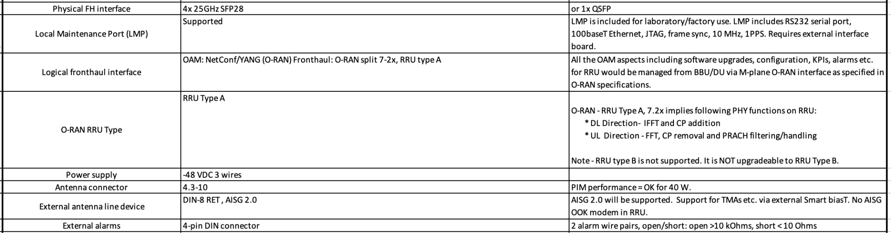

Dual-Band RRU External Interface Requirements

# Onboard Power System

*Please describe the architecture of the power systems and requirements in your contribution.*

*Note to author of this specification: This section can include the following but is not limited to the below items:*

* *Voltage Regulation*
* *Power Management*
* *Input voltages*
* *Hot swap controller circuit*
* *Hard drive power*
* *Power Tree*
* *Power Policy*
* *Power Budget*
* *Platform Budget*
* *Capacitive Load*

# Prescribed Materials

*Please list any prescribed materials in your contribution. Specific components that are being referenced but not contributed.*

*Note to author of this specification: This section can include the following but is not limited to the below items:*

* *Disallowed components*

*Any specifically required components with no substitution (Ex: IC Intel JHL8540 or greater for Thunderbolt 4 compliance)*

# System Firmware

*Please document firmware function, and necessary features, licensing and distribution rights, explanation of ownership rights, system build utilities, test regime explanations, standards compliance, options for changing firmware configurations, and how firmware upgrades can be accomplished.*

*Note to author of this specification: This section can include the following but is not limited to the below items:*

* *BIOS Chip*
* *BIOS Feature Requirements*

# Hardware Management

*Please document the hardware management implementation of your contribution. Include Firmware (BIOS) optional Board Management Controller (BMC), Data Center Secure Control Modules (DC-SCM), etc.*

*Note to author of this specification: This section* ***should*** *include the following below items:*

* *Statement on whether the contribution supports out-of-band manageability.*
* *Statement on the modularity of the manageability architecture. (i.e. is an OCP management module used?)*

*Note to author of this specification: This section* ***can*** *include the following but is not limited to the below items:*

* *Architecture of out-of-band management*
  + *Dedicated or shared NIC*
  + *In which power state is the OOB management enabled*
* *A list of on-platform manageability interfaces:*
  + *Connections: I2C/I3C, SMBus, RMII,*
  + *Transport Protocol: MCTP, IPMI (KCS, BT, etc)*
  + *Commands constructs: PLDM …, IPMI, SPDM, CPER*
* *A list of components whose firmware which can updated programmatically*
  + *Which support failover/rollback mechanisms*
* *A list of diagnostic or management LEDs supported*
* *A list of minimum telemetry/sensors*
* *A list of minimum controls*
* *Whether conformance to OCP Profiles has been tested*
* *For Arm-based Servers, whether conformance to Arm Server Base Manageability Requirements Specification has been followed. If so, please also indicate the conformance level (e.g., M2)*

# Compliance

*This* ***mandatory*** *section is also applicable to create the checklist for the consumers of the specification to adhere to in order for them to declare it complies to the requirements. This applies to any implementations (OCP Marketplace or not) that declare compliance with this specification.*

*(Example Compliance Table Follows)*

| ***ITEM*** | ***REQUIREMENT*** | ***REFERENCE*** | ***MANDATORY*** |
| --- | --- | --- | --- |
| *1* | *If scalable HPM depth >372.5mm (from origin), additional Zone 2 KOZs shall be*  *implemented.* | *10.3.2 (multiple items)* | *Y* |
| *2* | *Optional: The device shall only clear the Timestamp Origin field to 000b in the Timestamp (Feature*  *Identifier 0Eh) on a main power cycle or NVM Subsystem Reset (e.g., NSSR). The device*  *shall not clear the Timestamp Origin field on a power cycle of only AUX power.* | *NVMe-OPT-4* | *N* |
| *3* | *Any supplier seeking OCP recognition for a hardware product based on this specification*  *shall be 100% compliant* | *4* | *Y* |

*All Products seeking OCP Accepted™ Product Recognition shall have source code and binary*

*blobs submitted for BMC, if applicable.*

*The BMC management source code shall be uploaded at:*

[*https://github.com/opencomputeproject/Hardware-Management/[vendor_name]/[product_name*](https://github.com/opencomputeproject/Hardware-Management/%5Bvendor_name%5D/%5Bproduct_name)*]*

# Security

*Please briefly describe security functionality that* ***your specification requires and recommends\*****.*

*Include a “required by” date on recommendations. Omit what doesn’t apply and add whatever*

*is missing. Remember, the greater the detail in this specification, the less flexibility is allowed during design and product specification.*

* *For cryptography, key derivation, key agreement, and hashing, identify*

*o Required algorithms, modes, strengths, and usage*

*o Required compliance with national or international standards*

*o Acceptable sources of entropy*

*o Acceptable certifications of algorithm implementations*

*o Recommended certifications of cryptographic modules*

*o Recommended safeguards against cryptanalysis by quantum computers*

* *Required flow of Secure Boot starting from hardware root(s) of trust*
* *Required measurements from hardware reset through firmware*
* *Required attestation protocols*
* *Acceptable environments and processes for provisioning keys and device secrets*
* *Acceptable processes for identifying CVEs and distributing field updates to address them*
* *Acceptable Secure Boot and Attestation key lifecycle management (from generation through*
* *revocation)*
* *Recommended standards for software bills of materials*
* *Recommended firmware recovery mechanisms*

*\*Required = Required now*

*Acceptable = Required now and chosen from a list of acceptable alternatives*

*Recommended = Recommended now, but required by a specified future date*

*Please find guidance and examples in the OCP Security Project documents on* [*Secure Boot*](https://www.opencompute.org/documents/secure-boot-2-pdf)*,* [*Attestation of System Components*](https://www.opencompute.org/documents/attestation-v1-0-20201104-pdf)*,* [*Common Security Threats*](https://www.opencompute.org/documents/common-security-threats-notes-1-pdf)*, and the* [*CSIS document on Secure Firmware Development Best Practices*](https://www.opencompute.org/documents/csis-firmware-security-best-practices-position-paper-version-1-0-pdf)*.*

All products seeking OCP Inspired™ or OCP Accepted™ Product Recognition shall have a

completed Security Profile in the 2021 Supplier Requirements Checklist. Whether the answer is

a yes or no, the profile must be completed.

# Software Support (recommended)

*Please identify any software and/or tools used to validate the hardware design and include test and validation using virtual simulation, design decisions based upon digital models, or proof of manufacturability via 3-D tools.*

# Arm SystemReady (only for Arm-based Systems)

*Please document the requirement for this design to be compliant with the ARM SystemReady specifications.*

*For Server Sleds, Open Edge Sleds and Monolithic Servers, the certification of either SystemReady SR or LS certification is required.*

*For Storage and Networking, the certification of SystemReady SR, LS, ES, or IR is recommended.*

*For Systems that are SystemReady SR, ES or IR certified, SystemReady Security Interface Extension (SIE) certification is recommended.*

*More details on Arm SystemReady can be found at https://www.arm.com/architecture/system-architectures/systemready-certification-program.*

# References

1. “Title”, publication year, publication journal/conference/standard, volume, pages, link to publication if available

# Appendix A - Checklist for IC approval of this Specification (to be completed by contributor(s) of this Spec)

Complete all the checklist items in the table with links to the section where it is described in this spec or an external document .

| **Item** | **Status** | **Link to detailed explanation** |
| --- | --- | --- |
| Has this contribution been presented to an OCP Project group during a project call or engineering workshop? | Yes or No | If “No”, please state the reason. |
| Approval by Project Leads | Yes or No | If “No”, please state the reason. |
| Is this contribution entered into the OCP Contribution Portal? | Yes or No | If “No”, please state the reason. |
| Was it approved in the OCP Contribution Portal? | Yes or No | If “No”, please state the reason. |

# 

# Appendix B - Contribution Process FAQs

As a contributor to a hardware specification, here are some questions that often come up.

1. **What type of specification am I contributing to OCP?**
   1. **The base specification** for a de-facto standard (ex: interface type)
   2. The base specification for a product <product type> (product may be coming but within the next 1-2 years)
   3. Modification of an existing <type> specification (state which existing spec is being modified) resulting in a revised specification.
   4. **Design specification** (based on an existing base specification) with more refined design details (product coming in 12-15 months)
   5. A detailed **Product specification** for a <product type> for a very specific product being available in 3-6 months of approval of this Spec
   6. If none of the above, please contact OCP Staff for better direction.
2. **How do I know if what I am contributing will be accepted by OCP?**
   1. Before contributing any specifications, please contact either OCP Staff (Rob Coyle, Michael Schill) or the Project Lead for the Project that best represents your contribution. They will guide you as to what’s the best form for your contribution. Project List [here](https://www.opencompute.org/projects).
3. **What is the contribution process for my hardware spec?**
   1. Follow the flow for your spec type [here](https://docs.google.com/presentation/d/1PlXGLhCdgVEGWQ0hLYdAQEH5qCScwYij/edit#slide=id.g10e20dc1292_0_101).
4. **What if my spec is not developed yet and I want to collaborate with other companies?**
   1. Please contact either OCP Staff (Rob Coyle or Michael Schill) or the Project Lead for the Project that best represents your contribution. They will help you find other collaborators and help you with the contribution process for a multi-party contribution.
5. **I have a question about the Contribution License Agreement (CLA).** 
   1. Please contact OCP Staff and we can help you with questions.
6. **Do I need to have a product in order to make a contribution?**
   1. Please see Q1. Some types of contributions do not result in a product. Some examples are whitepapers, case studies, OCP Ready Assessment, etc.. Please work with the OCP Staff on the better direction on your specification type.